

System Provisioning and Configuration Management Lab



**Submitted by:  
Aryan Karnwal  
500101796  
R2142220239  
Devops B2(NH)**

**EXPERIMENT 4**

Lab Exercise: Executing Ansible Modules

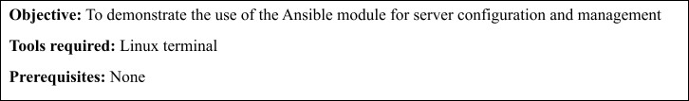

Steps to be followed:

1. Use Ansible modules for server configuration

Step 1: Use Ansible modules for server configuration

* 1. 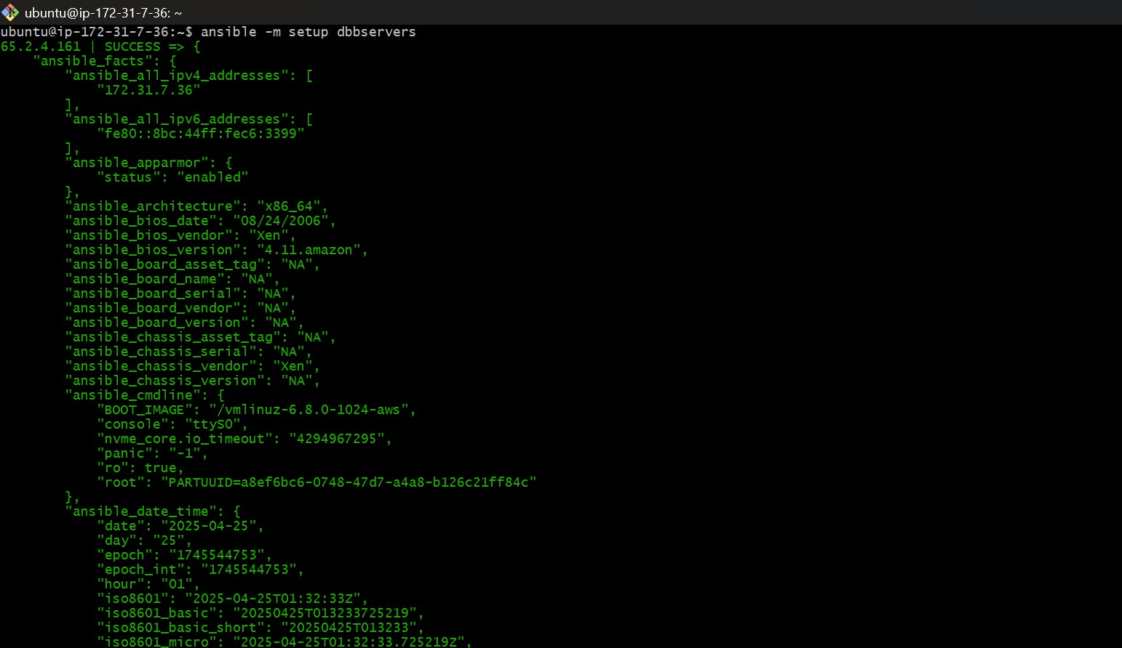Run the following command using the **setup** module to collect and display detailed system information about the servers: **ansible -m setup dbbservers**
  2. Run the following command using the **shell** module to retrieve server hostnames:

ansible dbbservers -m shell -a 'hostname'

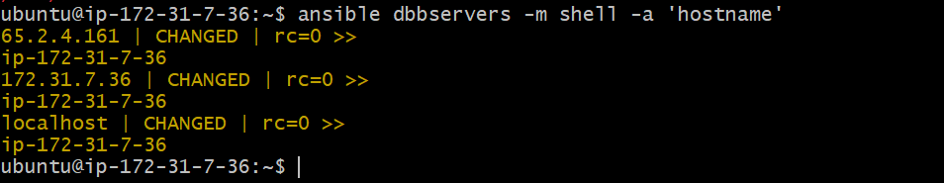

* 1. Run the following command using the **apt** module to install Git on servers:

ansible dbbservers -m apt -a 'name=git state=present update_cache=true' --become

